28.3L Dust Particle Counter
User Manual
Product Model: DPC-1303
Version: V1.05
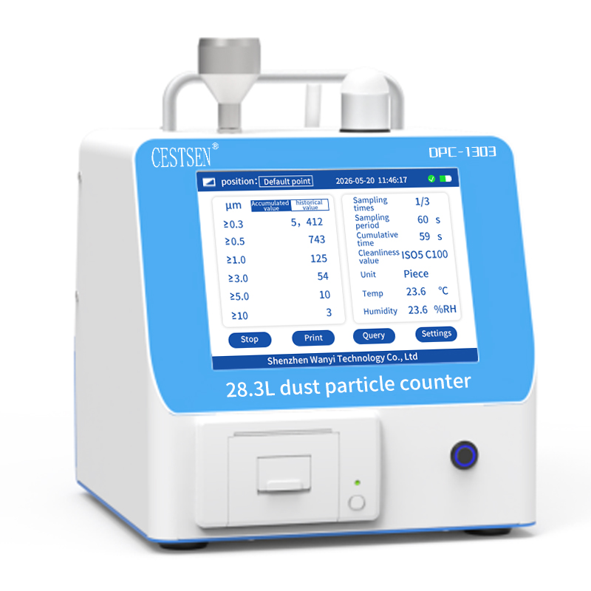
SHENZHEN WANYI TECHNOLOGY Co., Ltd.
User Notice
- Please read this instruction manual carefully before use, follow the operating procedures and precautions in this manual , and keep it for reference.
- Upon receiving the equipment , please carefully open the packaging and inspect the equipment and accessories for any damage caused during transportation. If any damage is found, please notify the manufacturer or distributor immediately.
- Using the equipment in ways other than those specified in the manual may damage it. Do not place the equipment in toxic, harmful, corrosive, or radioactive environments .
- There are no user-maintainable parts inside the equipment. If the equipment malfunctions , please contact the manufacturer or distributor directly . Modifying or disassembling the equipment yourself will void the warranty .
- The disposal of waste electrical and electronic products shall comply with the relevant national requirements on comprehensive resource utilization, environmental protection, occupational safety and protection of human health.
Table of contents

Product Overview 1
Working principle 1
Scope of application 2
Features​ 2
Technical indicators 3
Product specifications (unit: mm) 5
Interface Description 6
Operating Instructions 7
Maintenance and Repair 20
Equipment scrapping 20
Equipment and accessories details 21
Appendix: 23
DPC1303 Dust Particle Counter Modbus Quick Start Protocol 23
1. Communication parameters 23
2. Communication Format 23
3. Device MODBUS register address information 25
4. Exception response fault codes 32
5. CRC check algorithm 32
6. Register Details Example 33

Product Overview
DPC1303 28.3L Dust Particle Counter is a multi-channel dust particle counter based on the principle of single-particle laser scattering. It can accurately detect 6 channels of particles with an industry-standard size of 0.3μm, 0.5μm, 1μm, 3μm, 5μm, and 10μm. It supports multiple communication interfaces, transmitting data to various smart terminals in real time, reducing human intervention and achieving unmanned intelligent monitoring. It is suitable for various occasions with cleanliness monitoring requirements.
DPC1303 28.3L Dust Particle Counter is designed based on professional particle counter standards. It adopts industrial-grade lasers and large-aperture optical components, combined with Nova latest generation of light scattering particle signal processing technology, which has higher detection accuracy and particle size resolution. This allows it to be compared with a variety of professional standard equipment and meet data accuracy requirements.
DPC1303 28.3L Dust Particle Counter features a high - negative-pressure constant-flow air source with built-in closed-loop feedback control and a high-efficiency filter at the outlet, effectively preventing pollution of the sampling environment. It comes standard with USB, RS485 , and Ethernet communication interfaces , along with a wealth of interactive functions, covering most usage scenarios. Its diverse functions and communication methods meet the needs of different customers.

Working principle
Employing the principle of single-particle laser scattering, a precise optical design and an air path designed according to fluid dynamics principles ensure that particles in the sampled air pass through the laser beam with a high probability, generating weak scattered light. A precise optical signal collection device gathers this scattered light and projects it onto a highly sensitive, high-bandwidth, large-area photodetector. By identifying and analyzing the scattering pulse of each particle, the signal intensity corresponding to each particle is obtained; through a calibration procedure, the particle size of each particle is determined; and after conversion and aerodynamic calibration, the number of particles is obtained.

Scope of application
DPC1303 28.3L Dust Particle Counter is widely applicable to cleanroom particle counting detection scenarios in industries such as semiconductors, pharmaceuticals, electronics, food processing, and precision machining .

Features​
- Accurate data : Utilizing the principle of single-particle laser scattering and paired with an industrial-grade laser light source, it boasts excellent counting efficiency and outstanding repeatability and consistency of test results .
- Particle size range: The detection particle size range is 0.3 ~ 10 μm , a single device covers 6 particle size channels, and supports custom display of channels .
- High reliability: Supports self-testing of optical and air paths, aerodynamic correction, insensitive to vibration, and high system reliability and stability .
- Stable flow rate: Standard flow rate 28.3 L/min , using active sampling gas source , combined with PID flow closed-loop control , can support stable, long-term, high negative pressure sampling .
- High efficiency and self-cleaning: Built-in high-efficiency filter can effectively avoid contamination of the sampling environment .
- Second-level response: Data update rate reaches the second level, with timely and efficient response.
- Comprehensive functionality: Allows setting sampling points, sampling frequency, and sampling time to achieve periodic interval sampling.
- Easy- to-use interface: Equipped with an 8-inch color touchscreen, supporting both real-time and cumulative data modes, and flexibly converting data units [PC, PC/ft³, PC/m³].
- Convenient communication: Standard configuration includes multiple data acquisition and communication interfaces : USB, RS485, Ethernet .
- Local storage: Supports local storage, storing 7 million data entries, and can export files via Type-C interface .
- Built-in printer: Embedded high-speed thermal printer with customizable print content, supports manual / automatic printing, and real-time recording of counting results.
- Audible and visual alarm: Standard configuration includes an audible and visual alarm , with options for cleanliness level alarms or user- defined alarm values .
- Long battery life: Built-in high-capacity battery, with a battery life of up to 8 hours.
- Circuit safety: ESD, overvoltage, overcurrent, and reverse connection protection; no radiation source and no light pollution .

Technical indicators
No. | project | parameter | Remark
1 | Particle size channel | 0. 3μm, 0.5μm, 1.0μm, 3.0μm, 5.0μm, 10.0μm | 6 channels  Custom display
2 | Sampling flow rate | 28.3L/min
3 | Counting efficiency | 0.3 μm/50%, >0.45 μm /100% | According to ISO 21501-4
4 | upper limit of concentration | 1,000,000 PC/ft³
5 | Self-cleaning time | ≤ 10min | The count is zero three times in a row within 10 minutes.
6 | Number of samples | Adjustable from 1 to 999 times
7 | Sampling time | Adjustable from 1 to 60000 seconds
8 | Sampling interval | Adjustable from 10 to 60000 seconds
9 | laser source | Long-life laser diodes
10 | Screen display | 8-inch color touchscreen
11 | Printing method | Embedded thermal printing
12 | Communication methods | USB, RS485, Ethernet | Optional wireless communication
13 | Communication Protocol | Modbus-RTU/TCP
14 | Data storage | 7 million data entries | Queryable and exportable
15 | Power supply | Air pump: DC 16.8V / 5A  Fan: DC 16.8V / 3A
16 | Battery life | Air pump: 6 hours; Fan: 8 hours
17 | Operating power | Air pump: 35W ; Fan: 25W
18 | Reference Standard | ISO 21501-4, GB T29024.4-2017,  JJF 1190-2008
19 | Work environment | Temperature -20~60℃, humidity 20~95%RH | No condensation
20 | size | Air pump: 240*295*285mm  Fan: 240*250*285mm
21 | weight | Air pump: 7 kg; Fan: 5 kg

Product specifications (unit: mm)
[Air Pump Model]
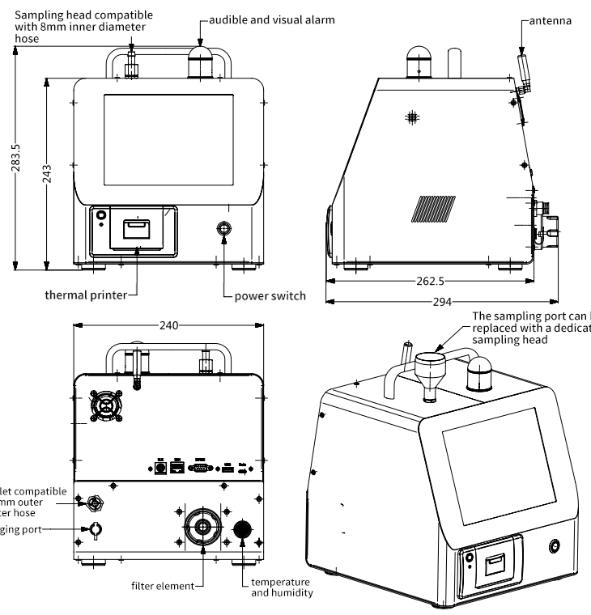
[ Fan Model]
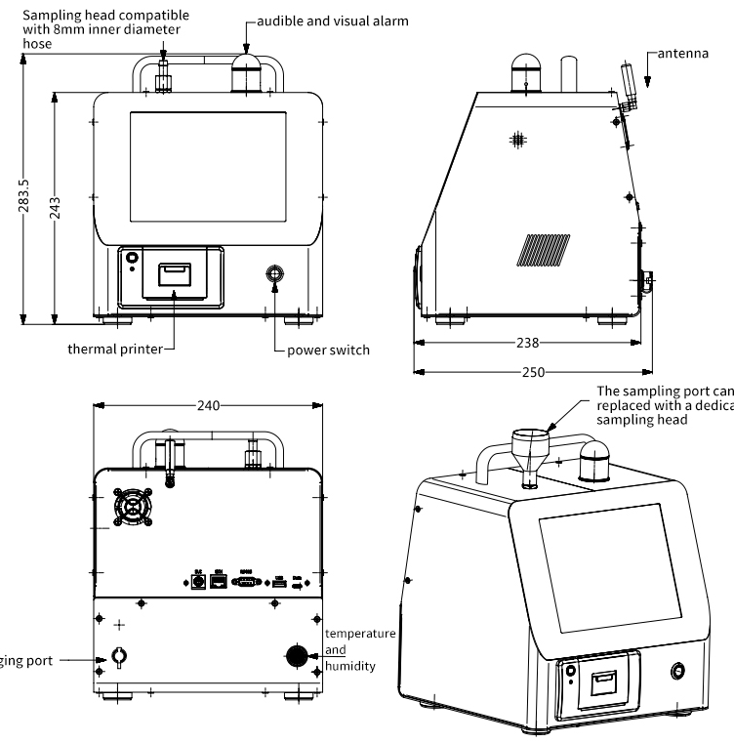

Interface Description
No. | name | Function | Remark
1 | Data | Data export | Type-C interface
2 | USB | Communication and data acquisition | Standard USB interface
3 | RS485 | Communication and data acquisition | DB9 female port, pin definitions are as follows:  3- legged : A+ , 7 -legged : B-  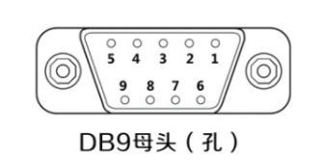
4 | ETH | Communication, data acquisition, IP configuration | RJ45 interface
5 | EUI | Extended reservation | PS2-6P interface

Operating Instructions
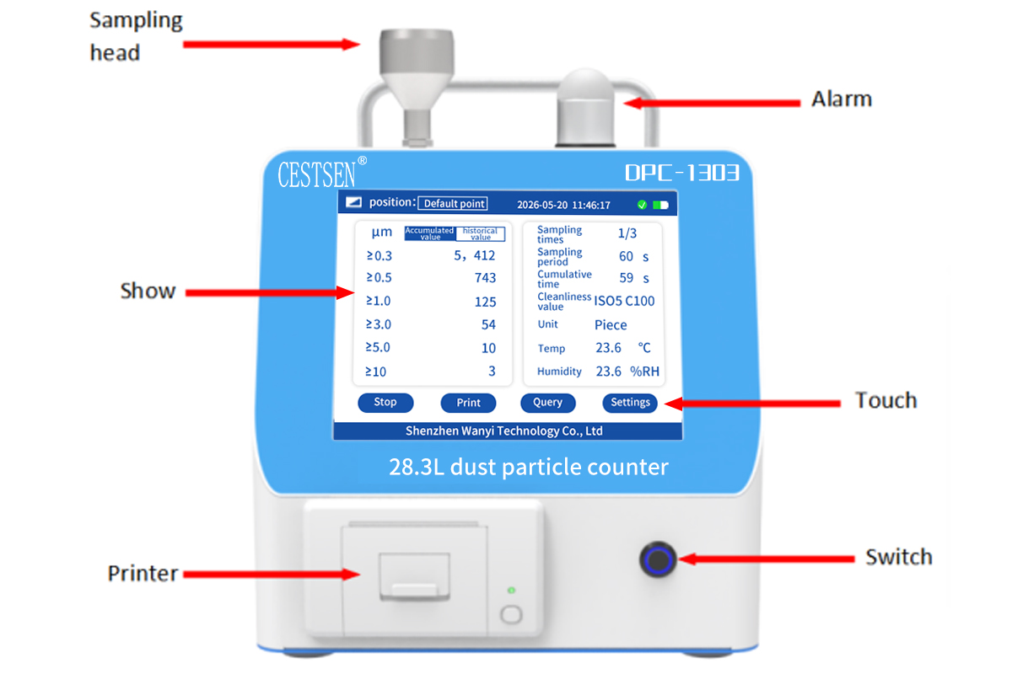
- Power on/off
Press the power switch or plug in the power source. The screen will display a startup animation. After about 3 seconds, the display interface will appear, indicating successful startup. Press the power switch again or unplug the power source. The screen will turn off and the device will shut down.

[Interface Display]
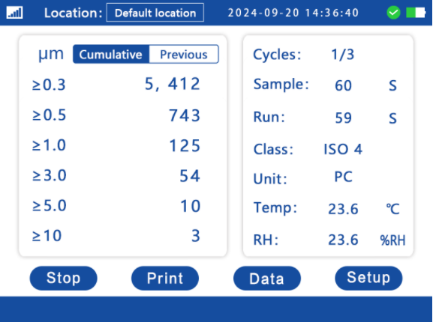
- model
DPC1303 28.3L Dust Particle Counter has three data display modes: "Real-time" [ Real-time Counting Mode ] , "Cumulative" and "Previous" [ Accumulated Value Counting Mode ]. In the accumulated value counting mode , you can switch between the standby and running states by clicking.
The "Real-time" displays the current particle number concentration.
The "Cumulative" displays the number/concentration of particles accumulated in the current sampling period.
"Previous" displays the test results from the previous sampling period.
- aisle
DPC1303 28.3L Dust Particle Counter supports custom display of particle size channels. It can display all data from 8 particle size channels simultaneously, or display the detection data of a specific particle size channel according to the settings.
- parameter
Each channel, DPC1303 28.3L Dust Particle Counter also displays relevant parameters, including "Location", "Cycles", "Sample", "Run", "Class", " Unit ", and " Temp and RH".
Location: Current sampling point location. Click to modify.
Cycles: The current number of samplings and the total number of samplings set.
Sample: The working time set for the current sampling period.
Run: The running time of the current sampling period.
Class: ISO cleanliness level.
Unit: The unit corresponding to the displayed data .
Temp and RH: Ambient temperature and humidity.

[Status Display]
DPC1303 28.3L Dust Particle Counter displays various device parameters in real time and shows them in the status bar. If any related problems occur, it will promptly provide feedback to the user and make adjustments.
- Battery
The battery status display is located in the upper right corner of the screen. The green block in the battery icon indicates the current battery level. When charging, the battery icon will have an animation of being filled with green. When the battery icon turns completely green, the battery is fully charged.
Please use the power adapter that came with the product to charge !
- flow
The data usage status is displayed in the upper right corner of the screen. After the detection starts, it will monitor the data usage status in real time. When the data usage status is normal, an icon will be displayed; when the data usage status is abnormal, an icon will be displayed.
If the abnormal traffic icon lights up, please stop the device immediately and check the device according to the following steps:
1. Check if there are any obstructions at the sampling port and exhaust port. If so, remove the obstructions in time and keep the air passage unobstructed.
2. Check whether the sampling head and the hose connected to the sampling head maintain good sealing and whether there is any obvious air leakage. If so, please replace the hose or reinstall the sampling head in time.
3. Check the cleanliness of the filter element inside the filter cartridge. If there is blockage or obvious foreign matter, replace the filter element in time and blow the filter tank with compressed air.
4. If no abnormalities are found after the above checks, please contact the manufacturer's after-sales service or the distributor in a timely manner.
- printer
Under normal conditions, the printer indicator light is solid green; if the paper is used up or the paper is placed incorrectly, the indicator light will flash red. Please replace or reposition the paper.
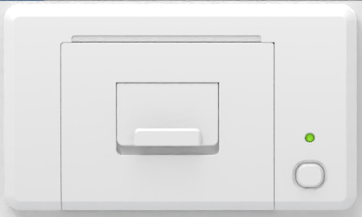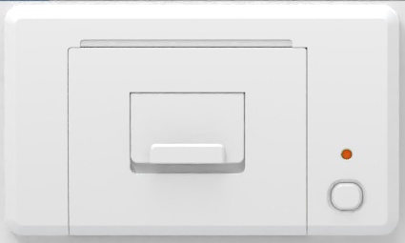

[Data Monitoring]
- Sampling and Detection
After the equipment is powered on, it enters standby mode. First, set the relevant parameters according to the testing requirements. Then, fix the isodynamic sampling head and the sampling bracket. Remove the dust caps from the isodynamic sampling head and the equipment's sampling air inlet. Take out the sampling tube, connect one end to the isodynamic sampling head's air outlet, and the other end to the equipment's sampling air inlet. Click the button to start sampling and testing.
After the test is completed, disconnect the hose at one end of the isodynamic sampling head and connect it to the air outlet of the device. Press the button to perform self-cleaning. Wait for the data to drop to 0 before self-cleaning is complete. Press the button again to stop the sampling test and enter standby mode. Cover the dust cap of the sampling air inlet and the isodynamic sampling head, and press the switch to turn off the device.
- Data Query
DPC1303 28.3L Dust Particle Counter supports historical data query. Click the button to enter the historical data interface, where you can view and print 100 sets of historical data.
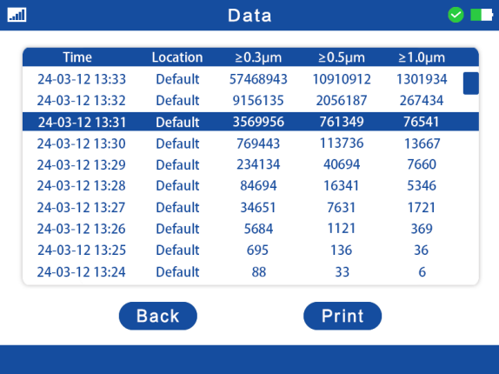
- Data printing
DPC1303 28.3L Dust Particle Counter has a built-in printer that supports manual / automatic printing of real-time and historical data for timely record-keeping.
Manual printing: You can click the button on the detection interface to print real-time data, or you can enter the historical data page, select the data group, and print the selected historical data.
Automatic printing: Enable the automatic printing function in the settings. In the cumulative value counting mode, the detection results of the current sampling period will be automatically printed after each sampling and detection cycle is completed.

【Product Settings】
After the device is powered on, it can be configured. Click the button to enter the settings page, where you can set [Time], [Mode], [Alarm], [Unit], [Channel], [Other], and [Language].
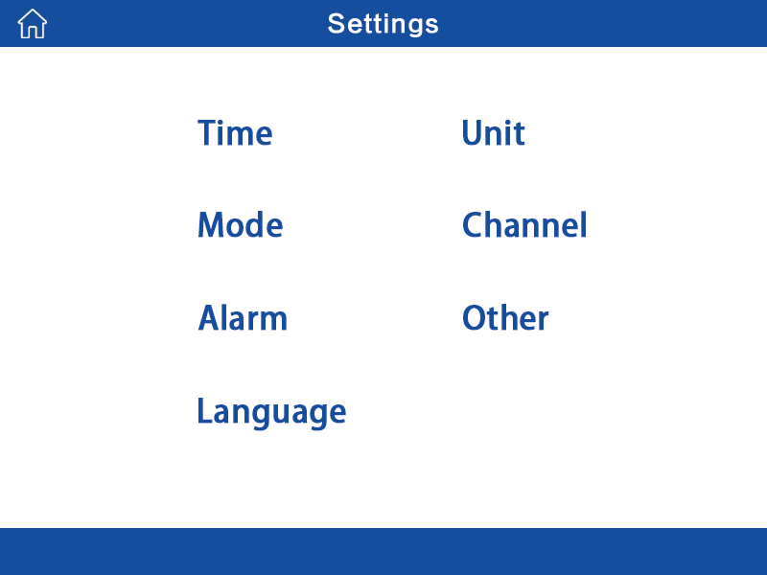
- Time settings
Click on the date or time parameter you want to modify, enter the setting value, and then click the button to apply the settings.
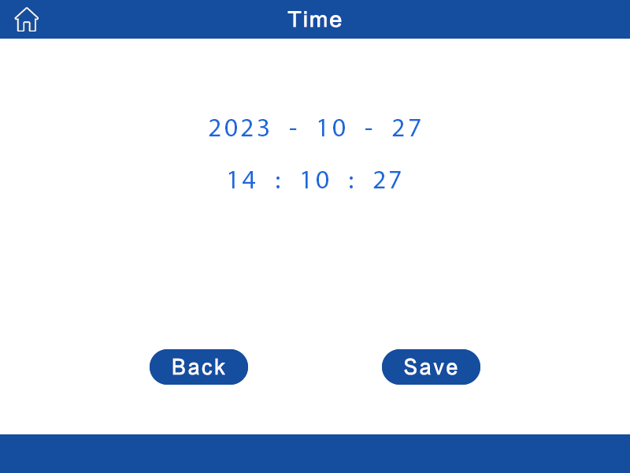
- Mode settings
DPC1303 28.3L Dust Particle Counter supports configuration of the [ Continuous Mode ] , [ Real-time count ] , [ Interval Mode ] , [ Cumulative Count ], and [ Sample Cycles ] to meet the needs of different application scenarios. Click the button to select the working mode, enter the working time and number of operations, and then click the button to apply the settings. The specific effect is as follows:
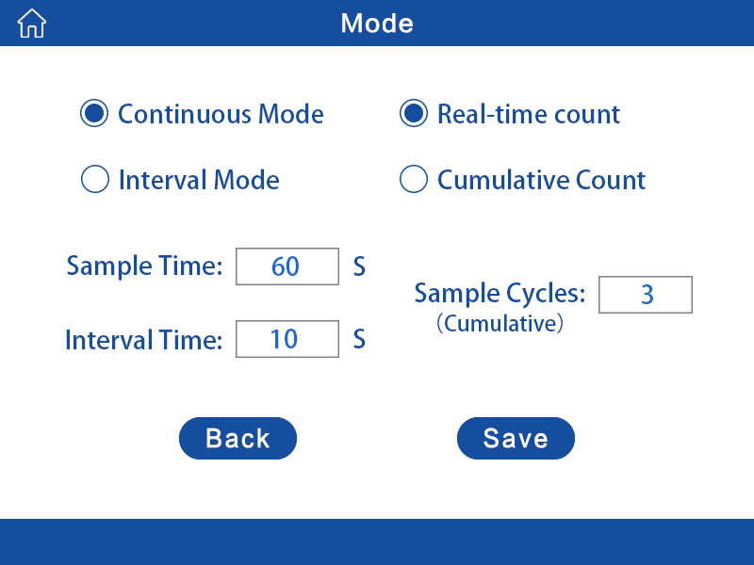
Work mode
1. Continuous working mode: The equipment continuously samples.
2. Interval working mode: The equipment will work in cycles according to the [Sample Time] and [Interval Time].
Counting mode
1. Real-time counting mode: The sampling interface displays data in "real-time value" mode, showing the quantity concentration. The data unit is consistent with the set unit, but cannot be "PC".
2. Cumulative Counting Mode: The device will accumulate the number of particles according to the [Sample Time] and perform periodic sampling according to the [Sample Cycles]. The sampling interface displays the data in the modes of "Cumulative" and "Previous".
"Cumulative" represents the cumulative number of particles in the current sampling period, with the data unit being [PC]. The data is cleared after one sampling period is completed. " Previous " represents the detection result of the previous sampling period, with the data unit consistent with the set unit.
- Alarm settings
DPC1303 28.3L Dust Particle Counter supports audible and visual alarm functions, which are divided into channel numerical alarm and ISO level alarm . After selecting the alarm mode, entering the alarm threshold or level, click the button to apply the settings.
1. Numerical Alarm: Set the input alarm threshold and click the button to enable the corresponding channel's numerical alarm.
2. Alarm Level: Set the alarm level and click the button to enable ISO level alarm.
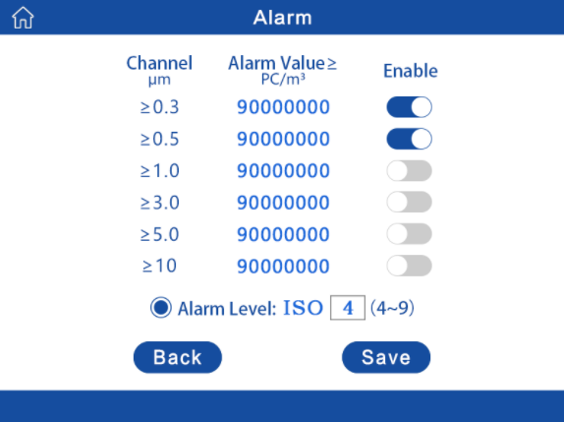
3. Cancel Alarm: When data exceeds the set alarm threshold or alarm level, the device will activate an audible and visual alarm, and a button will appear on the sampling display interface. Click to cancel the alarm. If sampling does not stop after canceling the alarm, the alarm will not recur for twice the working cycle (less than 10 minutes will be treated as 10 minutes).
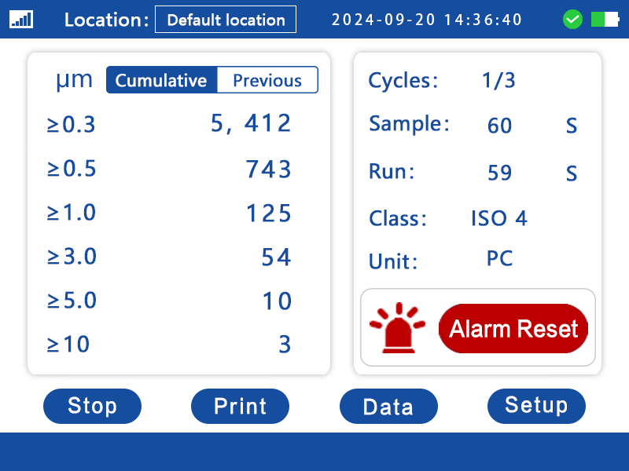
- Language Settings
DPC1303 28.3L Dust Particle Counter allows you to select different display languages: 中文and English. Click to select a language and click the button to apply the settings.
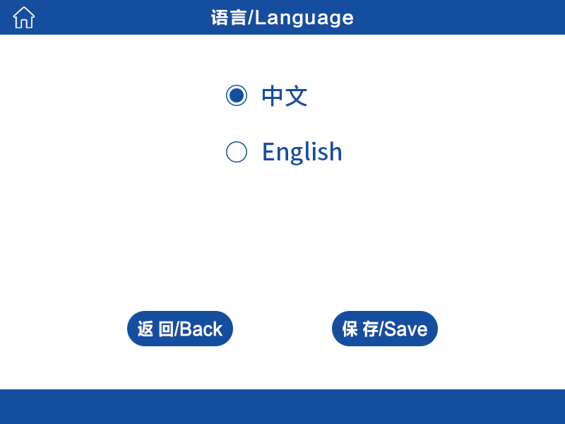
- Unit settings
DPC1303 28.3L Dust Particle Counter offers selectable data display units: [ PC/m³ ], [ PC/ft³ ], and [ PC ]. Click to select the unit, then click the button to apply the setting. (Note: "Real-time" cannot be in [ PC ])
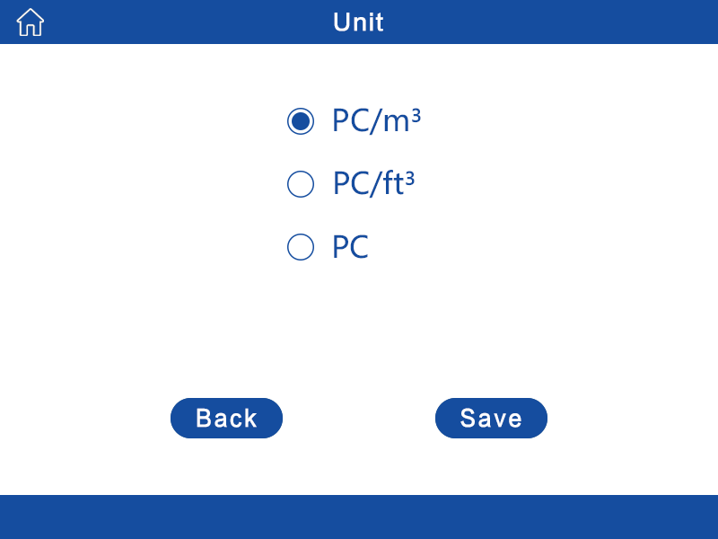
- Channel settings
DPC1303 28.3L Dust Particle Counter supports custom channel display configuration. Click the button to show or hide the corresponding particle size channel, and click the button again to apply the settings.
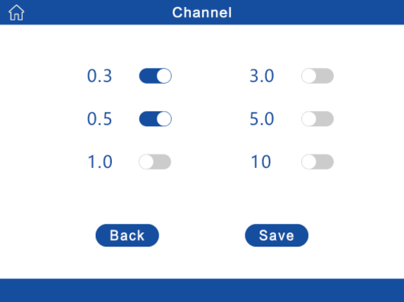
- Other settings
1. DPC1303 28.3L Dust Particle Counter supports configuration of the [Device Address ] and [ Baud Rate ] . After entering the settings, click the button to apply the settings.
2. Automatic printing function: In cumulative count mode, after each sampling and detection cycle is completed, the detection results of the current sampling cycle will be automatically printed. Click the button to enable it, and click the button to apply the settings.
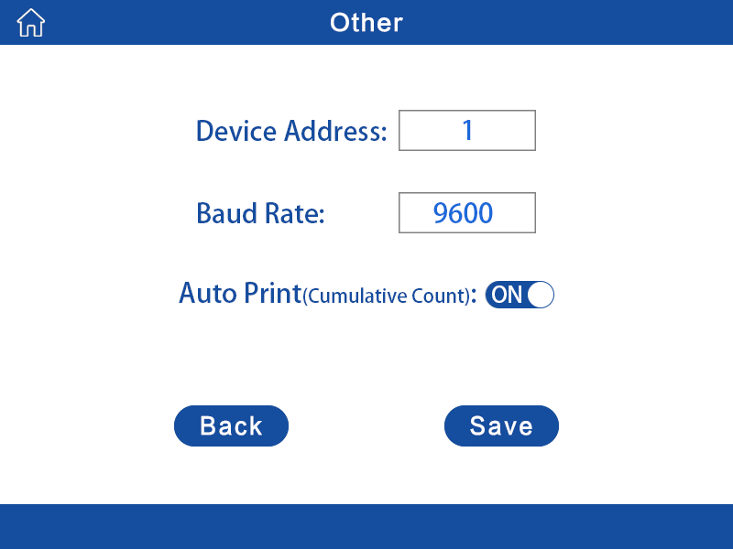

[Product Communication]
DPC1303 28.3L Dust Particle Counter features a multi-functional data acquisition and communication interface , allowing users to acquire data via USB, RS 485, ETH interface , or wireless communication (optional).
- Ethernet IP Configuration
Configure using the network port configuration software 【USR-M0_V2.2.5.8.exe】, as follows:
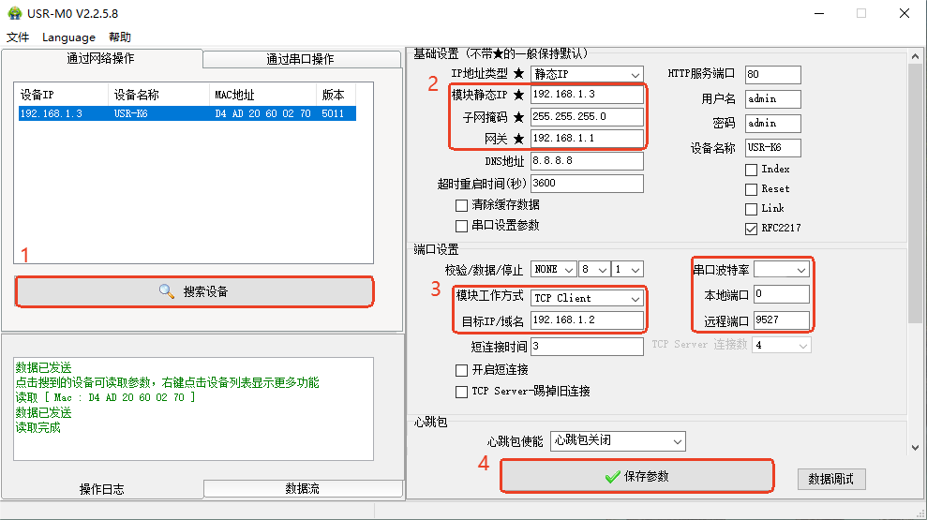
1. Connect the device to the switch or PC using a network cable via the device's ETH interface. After opening the software, click "Search Devices" and select the device after it is listed.
2. First, configure the device's IP address, subnet mask, and gateway. Set the static IP address to the same network segment as the connected computer, and be sure to select "Static IP" as the address type.
3. Next, set the module's working mode and target IP. The target IP is the IP address of the computer to which it is connected. Then, set the serial port baud rate to 9600 (consistent with the device) and the remote port to 9527.
4. Finally, click the "Save Parameters" button to complete the device IP configuration.

[Data Storage and Export]
- Data storage
The DPC1303 28.3L Dust Particle Counter creates a CSV file named "YYMMDDHH" (February 19, 2022, 13:00) each time it is powered on.
The file is created only once per hour. For example, if the computer is turned on and off twice within 13:00 and the data from both tests is stored in the same file, the file will be created again if the computer is turned on again at 14:00 after being turned off.
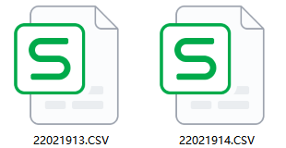
After sampling and detection are initiated, data storage begins. All data detected during this boot process will be stored in this file. If the device remains in standby mode after booting and no data detection is performed, the file will be empty.
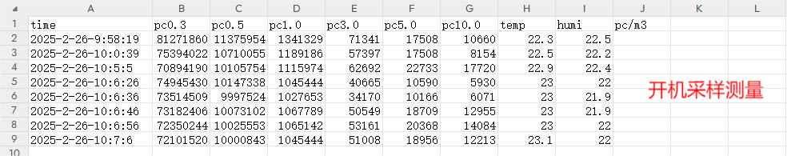
- Data export
The DPC1303 dust particle counter supports data export. Connect the Type-C end of the Type-C data cable to the Data port on the back of the device, and connect the USB end to the USB port of the PC. The device will appear as a USB flash drive, which can be opened to export the data.
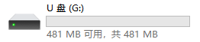

Maintenance and Repair
- Equipment maintenance
Dust particle counters are mainly used in cleanrooms for cleanliness monitoring. Under normal use, they will not be contaminated and generally require no other maintenance except for periodic calibration.
- Equipment calibration
According to the JJF1190-2008 Dust Particle Counter Calibration Specification, it is recommended that the calibration interval not exceed one year. The calibration method can be selected based on actual conditions, such as returning the device to the factory for standard particle calibration or performing channel coefficient calibration with standard equipment.
- Precautions
The recommended length of a single hose connecting the equipment should not exceed 1.5 meters. Longer hoses carry a greater load, making it easier for particles to accumulate and causing deviations in the test data. The hose should be a standard-specified PVC or silicone hose, preferably with an internal PTFE layer.

Equipment scrapping
Waste electrical and electronic products should comply with national requirements for comprehensive resource utilization, environmental protection, occupational safety, and protection of human health. It is recommended that they be handled by a qualified recycler.

Equipment and accessories details
name | Illustration | quantity | Remark
host | 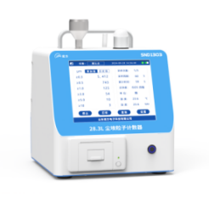 | 1
power adapter | 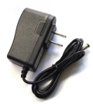 | 1
Type-C data cable | 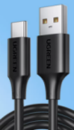 | 1
USB communication cable | 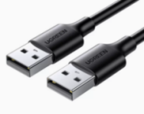 | 1
485 adapter | 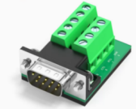 | 1
Isodynamic sampling head | 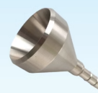 | 1
Sampling bracket | 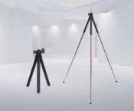 | 1
filter element | 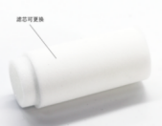 | 1 | Air pump model
Self-cleaning filter | 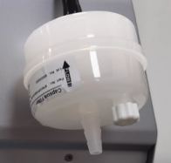 | 1 | Fan version
sampling tube | 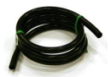 | 1
dust cap | 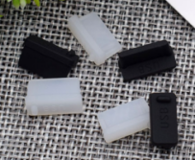 | 7
Thermal printing paper |  | 2 | 57*30mm
User Manual | 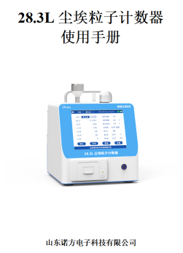 | 1
Factory quality inspection report | 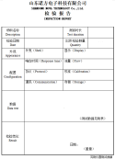 | 1
Certificate of Conformity | 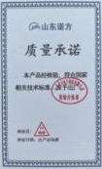 | 1
Equipment storage and transportation box | 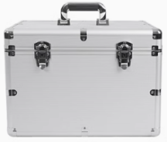 | 1

Appendix:

DPC1303 28.3L Dust Particle Counter Modbus Quick Start Protocol

1. Communication parameters
Communication protocol: Modbus RTU protocol
Communication data format: 8, N, 1 (1 start bit, 8 data bits, no parity, 1 stop bit)
Baud rate selection: 9600bps
Modbus protocol address: Default 0x01
Device response time: < 300ms
Query interval: 1 second. It is recommended to query at a maximum frequency of once per second.

2. Communication Format
(1) General frame format
address | Function code | Data area | CRC16
(2) Read operation request frame format
meaning |  | byte count | offset | Remark
address |  | 1 | 0
Function code |  | 1 | 1 | 0x03
Data area | Starting address | 2 | 2 | Register start address
Data area | Number of registers | 2 | 4 | Number of registers
Verification code |  | 2 | 6 | CRC16
(3) Read operation response frame format
meaning |  | byte count | offset | Remark
address |  | 1 | 0
Function code |  | 1 | 1 | 0x03
Data area | Byte count | 1 | 2 | Excluding itself, it indicates the number of bytes in the "data field".
Data area | Data domain | N | 3 | Number of bytes ("number of registers" * 2)
Verification code |  | 2 | N+3 | CRC16
(4) Write Single Register Operation Request Frame Format
meaning |  | byte count | offset | Remark
address |  | 1 | 0
Function code |  | 1 | 1 | 0x06
Data area | Starting address | 2 | 2 | Register start address
Data area | Data content | 2 | 4 | Data to be written
Verification code |  | 2 | 6 | CRC16
(5) Write Single Register Operation Response Frame Format
meaning |  | byte count | offset | Remark
address |  | 1 | 0
Function code |  | 1 | 1 | 0x06
Data area | Starting address | 2 | 2 | Register start address
Data area | Data content | 2 | 4 | Data to be written
Verification code |  | 2 | 6 | CRC16
(6) Write Multiple Register Operation Request Frame Format
meaning |  | byte count | offset | Remark
address |  | 1 | 0
Function code |  | 1 | 1 | 0x10
Data area | Starting address | 2 | 2 | Register start address
Data area | Number of registers | 2 | 4 | Number of registers
Data area | Byte count | 1 | 6 | Excluding itself, it indicates the number of bytes in the "data field".
Data area | Register 1 contents | 2 | 7 | Data to be written
Data area | Register 2 contents | 2 | 9 | Data to be written
Data area | ... | 2 |  | Data to be written
Data area | Register N contents | 2 | 7 + 2(N-1) | Data to be written
Verification code |  | 2 | 9+2(N-1) | CRC16
(7) Format of response frame for writing multiple register operations
meaning |  | byte count | offset | Remark
address |  | 1 | 0
Function code |  | 1 | 1 | 0x10
Data area | Starting address | 2 | 2 | Register start address
Data area | Number of registers | 2 | 4 | Number of registers
Verification code |  | 2 | 6 | CRC16

3. Device MODBUS register address information
project | describe | Remark
Device address | Default 0x01  0x00 is the broadcast address
Modbus function codes | 0x03 (Read holding register)
Modbus function codes | 0x06 (Preset Single Register)
Modbus function codes | 0x10 (Set multiple registers) | Only some registers are supported.
Modbus function codes | 0x81 Exception Response
Register address (2 bytes) | high byte
Register address (2 bytes) | low byte | Function address

Register group 1 (any register can be read)
No. | Decimal address (with 1 bit offset added) | hexadecimal address | describe | Data types | Register type | illustrate
1 | 1537 | 0x600 | Device address | 16-bit integer | R&W
2 | 1538 | 0x601 | baud rate | 16-bit integer | R&W | 2:4800  3:9600  4:19200  5:115200
3 | 1539 | 0x602 | Factory reset | 16-bit integer | R&W | 01: Restore factory settings
4 | 1540 | 0x603 | Status self-check | 16-bit integer | R | 0 indicates normal , 1 indicates abnormal.  Bit0 : Measurement not started  Bit1 : During intermittent work  Bit2 : Signal abnormal  Bit3 : Traffic anomaly  Bit4: Sensor communication error
5 | 1541 | 0x604 | Firmware version | 16-bit integer | R
6 | 1553 | 0x610 | High byte of real-time value for particle number greater than 0.3µm | 32-bit integer | R | 1. When the counting mode is real-time counting:  Units: PC/m³ or PC/ft³  2. When the counting mode is cumulative counting, it represents the cumulative value result within the previous sampling period. The unit is consistent with the setting: PC/m³ or PC/ft³ or PC.  3. Supports single-channel reading and simultaneous reading of 6 channels.
7 | 1554 | 0x611 | Low-order value of real-time particle number greater than 0.3µm | 32-bit integer | R
8 | 1555 | 0x612 | High byte of real-time value for particle number greater than 0.5µm | 32-bit integer | R
9 | 1556 | 0x613 | Low-order value of real-time particle number greater than 0.5µm | 32-bit integer | R
10 | 1557 | 0x614 | High byte of real-time value for particle number greater than 1µm | 32-bit integer | R
11 | 1558 | 0x615 | Low bit of real-time value of particle number greater than 1µm | 32-bit integer | R
12 | 1559 | 0x616 | High byte of real-time value for particle number greater than 3µm | 32-bit integer | R
13 | 1560 | 0x617 | Low bit of real-time value of particle number greater than 3µm | 32-bit integer | R
14 | 1561 | 0x618 | High digit of real-time number of particles greater than 5µm | 32-bit integer | R
15 | 1562 | 0x619 | Real-time value of particle number greater than 5µm (low bit) | 32-bit integer | R
16 | 1563 | 0x61A | High byte of real-time value for particle number greater than 10µm | 32-bit integer | R
17 | 1564 | 0x61B | Real-time value of particle number greater than 10µm (low bit) | 32-bit integer | R
18 | 1569 | 0x620 | Ambient temperature value | 16-bit integer | R | 1 fixed point decimal place
19 | 1570 | 0x621 | Ambient humidity value | 16-bit integer | R | 1 fixed point decimal place
20 | 1571 | 0x622 | Cleanliness level | 16-bit integer | R | ISO levels (4-9)
21 | 1572 | 0x623 | Alarm level settings | 16-bit integer | R&W | ISO levels (4-9)
22 | 1573 | 0x624 | Alarm level switch settings | 16-bit integer | R&W | 0 indicates a disabled alarm level,  and 1 indicates an enabled alarm level.
23 | 1574 | 0x625 | Alarm Status Register | 16-bit integer | R&W | 0 No alarm  1  Alarm After an alarm is triggered, the register value is set to 0 to temporarily cancel the alarm.  Once the alarm is canceled, it will not re-alarm within twice the working cycle (less than 10 minutes will be counted as 10 minutes).
24 | 1577 | 0x628 | Start and stop registers | 16-bit integer | R&W | 0 indicates stop measurement,  1 indicates start measurement
25 | 1578 | 0x629 | Continuous Intermittent Working Register | 16-bit integer | R&W | 0: Indicates that the sensor is set to work continuously;  1: Indicates that the sensor is set to work intermittently.
26 | 1579 | 0x62A | Sampling time register | 16-bit integer | R&W | 1~60000 seconds
27 | 1580 | 0x62B | Interval Time Register | 16-bit integer | R&W | 10~60000 seconds
28 | 1581 | 0x62C | PC0.3 Particle Number Calibration Factor | 16-bit integer | R&W | 0~60000 represents 0~600 times.
29 | 1582 | 0x62D | PC0.5 Particle Number Calibration Factor | 16-bit integer | R&W | 0~60000 represents 0~600 times.
30 | 1583 | 0x62E | PC1 particle number calibration factor | 16-bit integer | R&W | 0~60000 represents 0~600 times.
31 | 1584 | 0x62F | PC3 Particle Number Calibration Factor | 16-bit integer | R&W | 0~60000 represents 0~600 times.
32 | 1585 | 0x630 | PC5 Particle Number Calibration Factor | 16-bit integer | R&W | 0~60000 represents 0~600 times.
33 | 1586 | 0x631 | PC10 particle number calibration factor | 16-bit integer | R&W | 0~60000 represents 0~600 times.
34 | 1589 | 0x634 | Temperature calibration register | 16-bit integer | R&W | 1 fixed point decimal place
35 | 1590 | 0x635 | Humidity calibration register | 16-bit integer | R&W | 1 fixed point decimal place
36 | 1591 | 0x636 | Unit setting register | 16-bit integer | R&W | 01: PC(Available in cumulative count mode)  02: PC/ft³  03: PC/m³
37 | 1592 | 0x637 | Counting mode switching register | 16-bit integer | R&W | 0: Real-time count;  1: Cumulative count
38 | 1601 | 0x640 | The high byte of the cumulative number of particles greater than 0.3µm | 32-bit integer | R | This value represents the real-time cumulative value for the current sampling period. The unit is consistent with the setting: PC or PC/m³ or PC/ft³.  Valid in cumulative count mode.
39 | 1602 | 0x641 | The least significant bit of the cumulative number of particles greater than 0.3μm | 32-bit integer | R
40 | 1603 | 0x642 | The high byte of the cumulative number of particles greater than 0.5μm | 32-bit integer | R
41 | 1604 | 0x643 | The low digit of the cumulative number of particles greater than 0.5μm | 32-bit integer | R
42 | 1605 | 0x644 | The high byte of the cumulative number of particles greater than 1μm | 32-bit integer | R
43 | 1606 | 0x645 | The least significant bit of the cumulative number of particles greater than 1μm | 32-bit integer | R
44 | 1607 | 0x646 | The high digit of the cumulative number of particles greater than 3μm | 32-bit integer | R
45 | 1608 | 0x647 | The low digit of the cumulative number of particles greater than 3μm | 32-bit integer | R
46 | 1609 | 0x648 | The high digit of the cumulative number of particles greater than 5μm | 32-bit integer | R
47 | 1610 | 0x649 | The low digit of the cumulative number of particles greater than 5μm | 32-bit integer | R
48 | 1611 | 0x64A | The high digit of the cumulative number of particles greater than 10μm | 32-bit integer | R
49 | 1612 | 0x64B | The low-order digit of the cumulative number of particles greater than 10μm | 32-bit integer | R
50 | 1617 | 0x650 | PC0.3 alarm value setting high level | 32-bit integer | R&W | Unit: PC/m³
51 | 1618 | 0x651 | PC0.3 alarm value setting low bit | 32-bit integer | R&W | Unit: PC/m³
52 | 1619 | 0x652 | PC0.5 alarm value setting high level | 32-bit integer | R&W | Unit: PC/m³
53 | 1620 | 0x653 | PC0.5 alarm value setting low bit | 32-bit integer | R&W | Unit: PC/m³
54 | 1621 | 0x654 | PC1 alarm value set high | 32-bit integer | R&W | Unit: PC/m³
55 | 1622 | 0x655 | PC1 alarm value setting low bit | 32-bit integer | R&W | Unit: PC/m³
56 | 1623 | 0x656 | PC3 alarm value set high | 32-bit integer | R&W | Unit: PC/m³
57 | 1624 | 0x657 | PC3 alarm value setting low level | 32-bit integer | R&W | Unit: PC/m³
58 | 1625 | 0x658 | PC5 alarm value setting high level | 32-bit integer | R&W | Unit: PC/m³
59 | 1626 | 0x659 | PC5 alarm value setting low level | 32-bit integer | R&W | Unit: PC/m³
60 | 1627 | 0x65A | PC10 alarm value setting high level | 32-bit integer | R&W | Unit: PC/m³
61 | 1628 | 0x65B | PC10 alarm value setting low level | 32-bit integer | R&W | Unit: PC/m³
62 | 1633 | 0x660 | PC0.3 alarm switch settings | 16-bit integer | R&W | 1. Turn on the alarm switch.  0. Turn off the alarm switch.
63 | 1634 | 0x661 | PC0.5 alarm switch settings | 16-bit integer | R&W | 1. Turn on the alarm switch.  0. Turn off the alarm switch.
64 | 1635 | 0x662 | PC1 alarm switch settings | 16-bit integer | R&W | 1. Turn on the alarm switch.  0. Turn off the alarm switch.
65 | 1636 | 0x663 | PC3 alarm switch settings | 16-bit integer | R&W | 1. Turn on the alarm switch.  0. Turn off the alarm switch.
66 | 1637 | 0x664 | PC5 alarm switch settings | 16-bit integer | R&W | 1. Turn on the alarm switch.  0. Turn off the alarm switch.
67 | 1638 | 0x665 | PC10 alarm switch settings | 16-bit integer | R&W | 1. Turn on the alarm switch.  0. Turn off the alarm switch.
68 | 1649 | 0x670 | PC0.3 Threshold Channel | 16-bit integer | R&W | 0~65535  is for professional calibration. Fine-tuning is recommended;  when restoring factory settings, the threshold channel can be restored to its factory default value.
69 | 1650 | 0x671 | PC0.5 threshold channel | 16-bit integer | R&W
70 | 1651 | 0x672 | PC1 threshold channel | 16-bit integer | R&W
71 | 1652 | 0x673 | PC3 threshold channel | 16-bit integer | R&W
72 | 1653 | 0x674 | PC5 Threshold Channel | 16-bit integer | R&W
73 | 1654 | 0x675 | PC10 threshold channel | 16-bit integer | R&W

Register group 2 (full-function register)
project | describe | Supported function numbers | Remark
Register address ( 2 bytes ) | 0x0000(R&W): Device address | 0x06 Settings  0x03 Read | Readable and writable
Register address ( 2 bytes ) | 0x0003(R): Device firmware version | 0x03 Read | Read-only
Register address ( 2 bytes ) | 0x0005(R&W): Unit Setting Register | 0x06 Settings  0x03 Read | 01: PC( Available in cumulative count mode )  02: PC/ft³  03: PC/m³
Register address ( 2 bytes ) | 0x0007(R&W): Start/Stop Measurement Register | 0x06 Settings  0x03 Read | 0 indicates stop measurement  1 marks the start of measurement.
Register address ( 2 bytes ) | 0x0008(R&W): Continuous Intermittent Working Register | 0x06 Settings  0x03 Read | 0 indicates continuous operation  1 is intermittent work
Register address ( 2 bytes ) | 0x0009(R&W): Sampling Time Register | 0x06 Settings  0x03 Read | 1~60000 seconds
Register address ( 2 bytes ) | 0x000A(R&W) : Interval Time Register | 0x06 Settings  0x03 Read | 10~60000 seconds
Register address ( 2 bytes ) | 0x000C(R&W) : Counting mode switching register | 0x06 Settings  0x03 Read | 0 : Real-time counting  1 : Cumulative value count
Register address ( 2 bytes ) | 0x00A5(W) : Factory reset register | 0x06 Settings | Write operations are supported only.  01 : Restore factory settings
Register address ( 2 bytes ) | 0x00CD(R&W) : Baud rate setting register | 0x06 Settings  0x03 Read | 2 : 4800  3 : 9600  4 : 19200  5 : 115200
Register address ( 2 bytes ) | 0x00CE(R&W): Temperature register | 0x03 Read | Containing decimals
Register address ( 2 bytes ) | 0x00CF(R&W): Humidity register | 0x03 Read | Containing decimals
Register address ( 2 bytes ) | 0x00 D2 (R&W): Temperature calibration register | 0x03 Read  0x06 Settings | Containing decimals
Register address ( 2 bytes ) | 0x00 D3 (R&W): Humidity calibration register | 0x03 Read  0x06 Settings | Containing decimals
Register address ( 2 bytes ) | 0x1010: Status Self-Test Register | 0x03 Read | 0 indicates normal , 1 indicates abnormal.  Bit0 : Measurement not started  Bit1 : During intermittent work  Bit2 : Signal abnormal  Bit3 : Traffic anomaly  Bit4 : Device communication error
Register address ( 2 bytes ) | 0x1011~0x1012: Real-time value of the number of particles greater than 0.3µm | 0x03 Read | 1. When the counting mode is real-time counting:  Units: PC/m³ or PC/ft³  2. When the counting mode is cumulative counting, it represents the cumulative value result within the previous sampling period. The unit is consistent with the setting: PC or PC/m³ or PC/ft³.
Register address ( 2 bytes ) | 0x1013~0x1014: Real-time value of the number of particles greater than 0.5µm | 0x03 Read
Register address ( 2 bytes ) | 0x1015~0x1016: Real-time value of the number of particles greater than 1µm | 0x03 Read
Register address ( 2 bytes ) | 0x1017~0x1018: Real-time value of particle number greater than 3µm | 0x03 Read
Register address ( 2 bytes ) | 0x1019~0x101A: Real-time value of the number of particles greater than 5µm | 0x03 Read
Register address ( 2 bytes ) | 0x101B~0x101C: Real-time values of the number of particles greater than 10µm | 0x03 Read
Register address ( 2 bytes ) | 0x1031~0x1032: Cumulative number of particles greater than 0.3µm | 0x03 Read | This value represents the real-time cumulative value for the current sampling period. The unit is consistent with the setting: PC or PC/m³ or PC/ft³.  Valid in cumulative count mode.  Supports single-channel reading and simultaneous reading of 6 channels.
Register address ( 2 bytes ) | 0x1033~0x1034: Cumulative number of particles greater than 0.5µm | 0x03 Read
Register address ( 2 bytes ) | 0x1035~0x1036: Cumulative number of particles greater than 1µm | 0x03 Read
Register address ( 2 bytes ) | 0x1037~0x1038: Cumulative number of particles greater than 3µm | 0x03 Read
Register address ( 2 bytes ) | 0x1039~0x103A: Cumulative number of particles greater than 5µm | 0x03 Read
Register address ( 2 bytes ) | 0x103B~0x103C: Cumulative number of particles greater than 10µm | 0x03 Read
Register address ( 2 bytes ) | 0x10AD PC0.3 Particle number calibration factor | 0x03 Read  0x06 Settings  0x10 Settings | 0~60000 represents 0~600 times.
Register address ( 2 bytes ) | 0x10AE PC0.5 Particle number calibration factor | 0x03 Read  0x06 Settings  0x10 Settings | 0~60000 represents 0~600 times.
Register address ( 2 bytes ) | 0x10AF PC1 Particle number calibration factor | 0x03 Read  0x06 Settings  0x10 Settings | 0~60000 represents 0~600 times.
Register address ( 2 bytes ) | 0x10B0 PC3 Particle number calibration factor | 0x03 Read  0x06 Settings  0x10 Settings | 0~60000 represents 0~600 times.
Register address ( 2 bytes ) | 0x10B1 PC5 Particle number calibration factor | 0x03 Read  0x06 Settings  0x10 Settings | 0~60000 represents 0~600 times.
Register address ( 2 bytes ) | 0x10B2 PC10 Particle number calibration factor | 0x03 Read  0x06 Settings  0x10 Settings | 0~60000 represents 0~600 times.
Register address ( 2 bytes ) | 0x10C1 PC0.3 Threshold channel | 0x03 Read  0x06 Settings  0x10 Settings | 0~65535  For professional calibration; fine-tuning is recommended.  When restoring factory settings, the threshold channel can be restored to its factory default value.
Register address ( 2 bytes ) | 0x10C2 PC0.5 Threshold channel | 0x03 Read  0x06 Settings  0x10 Settings
Register address ( 2 bytes ) | 0x10C3 PC1 Threshold Channel | 0x03 Read  0x06 Settings  0x10 Settings
Register address ( 2 bytes ) | 0x10C4 PC3 Threshold Channel | 0x03 Read  0x06 Settings  0x10 Settings
Register address ( 2 bytes ) | 0x10C5 PC5 Threshold Channel | 0x03 Read  0x06 Settings  0x10 Settings
Register address ( 2 bytes ) | 0x10C6 PC10 Threshold Channel | 0x03 Read  0x06 Settings  0x10 Settings
Register address ( 2 bytes ) | 0x10D1~0x10D2 PC0.3 Alarm Value Settings | 0x03 Read  0x10 Settings | Only supports setting 6-channel alarm values and 10 commands.  Unit: PC/m³
Register address ( 2 bytes ) | 0x10D3 ~ 0x10D4 PC0.5 Alarm value settings | 0x03 Read  0x10 Settings
Register address ( 2 bytes ) | 0x10D5~0x10D6 PC1 Alarm Value Settings | 0x03 Read  0x10 Settings
Register address ( 2 bytes ) | 0x10D7~0x10D8 PC3 Alarm Value Settings | 0x03 Read  0x10 Settings
Register address ( 2 bytes ) | 0x10D9~0x10DA PC5 Alarm Value Settings | 0x03 Read  0x10 Settings
Register address ( 2 bytes ) | 0x10DB~0x10DC PC10 Alarm Value Settings | 0x03 Read  0x10 Settings
Register address ( 2 bytes ) | 0x10DD Alarm Level Settings | 0x03 Read  0x06 Settings | Setting range 4~9 ( ISO 4~9 )
Register address ( 2 bytes ) | 0x10E1 PC0.3 Alarm Switch Settings | 0x03 Read  0x06 Settings | 1. Turn on the alarm switch  0. Turn off alarm switch  set up
Register address ( 2 bytes ) | 0x10E2 PC0.5 Alarm Switch Settings | 0x03 Read  0x06 Settings
Register address ( 2 bytes ) | 0x10E3 PC1 Alarm Switch Settings | 0x03 Read  0x06 Settings
Register address ( 2 bytes ) | 0x10E4 PC3 Alarm Switch Settings | 0x03 Read  0x06 Settings
Register address ( 2 bytes ) | 0x10E5 PC5 Alarm Switch Settings | 0x03 Read  0x06 Settings
Register address ( 2 bytes ) | 0x10E6 PC10 Alarm Switch Settings | 0x03 Read  0x06 Settings
Register address ( 2 bytes ) | 0x10E7 Alarm Level Switch Settings | 0x03 Read  0x06 Settings | 1. Turn on the alarm switch  0. Turn off alarm switch
Register address ( 2 bytes ) | 0x10E 8 Alarm Status Register | 0x03 Read  0x06 Settings | 0 No alarms reported  1. Reporting an incident.  After an alarm is triggered, the register value is set to 0 to temporarily cancel the alarm. After the alarm is canceled, it will not re-alarm for twice the working cycle time (less than 10 minutes is counted as 10 minutes).

4. Exception response fault codes
Response frame format
Address code | Function code | Fault Codes | CRC low byte | CRC high byte
0x01 ( default ) | 0x8x | 1~4
1 byte | 1 byte | 1 byte | 1 byte | 1 byte
Fault Code:
1: Illegal function
Response frame (hexadecimal): 0x01 0x81 0x01 0x81 0x90
2: Invalid register address
Response frame (hexadecimal): 0x01 0x81 0x02 0xC1 0x91
3: Illegal value
Response frame (hexadecimal): 0x01 0x81 0x03 0x00 0x51
4: Slave equipment failure
Response frame (hexadecimal): 0x01 0x81 0x04 0x41 0x93

5. CRC check algorithm
uint16 CRC16(uint8 *Buf, uint32 usLen) {
uint16 i, j;
uint16 usCrc = 0xFFFF;
for ( i = 0 ; i < usLen ; i++ ) {
usCrc ^= Buf[i];
for (j = 0; j < 8; j++) {
if (usCrc & 1) {
usCrc >>=1;
usCrc ^=0xA001;
} else {
usCrc >>= 1;
}
}
}
return usCrc;
}

6. Register Details Example
Note: The number of particles read does not include fixed-point decimals. In the following examples, the messages are all in hexadecimal, and the unit of value is PC/m³ by default.
(1) Query device values
① Query the real-time particle count value of the device's 6 channels
The starting register address is 0x1011. To query the real-time value of the particle count for 6 channels, each channel's data occupies two registers, i.e., the value is 0x1011~0x101C. When the device has no data, the default value is 0xffffffff.
Supports single-channel reading and simultaneous reading of 6 channels.
The host sends |  | Reply from machine
Broadcast address | 00H | Slave address | 01H
Modbus function number | 03H | Modbus function number | 03H
Start register address (high byte) | 10H | Number of bytes returned | 18H
Start register address (low byte) | 11H | Particles larger than 0.3µm: Number block 1 ( high byte ) | 00H
Number of registers read (high byte) | 00H | Number of particles larger than 0.3µm | 00H
Number of registers read (low byte) | 0CH | Number of particles larger than 0.3µm | 0BH
CRC16 (low byte) | 10H | Particles larger than 0.3µm: Number block 4 ( low byte ) | 3BH
CRC16 (high byte) | DBH | Number block 1 ( high byte ) for particles larger than 0.5µm | 00H
 |  | Larger than 0.5µm particle bytes 2 | 00H
 |  | Larger than 0.5µm particles byte 3 | 01H
 |  | Particles larger than 0.5µm: Byte 4 ( low byte ) | 1AH
 |  | Particles larger than 1µm: byte 1 ( high byte ) | 00H
 |  | Larger than 1µm particles byte 2 | 00H
 |  | Larger than 1µm particles 3 bytes | 00H
 |  | Particles larger than 1µm: 4 bytes ( low byte ) | 4DH
 |  | Particles larger than 3µm: 1 byte ( high byte ) | 00H
 |  | Larger than 3µm particles byte 2 | 00H
 |  | Larger than 3µm particles byte 3 | 00H
 |  | Particles larger than 3µm: 4 bytes ( low byte ) | 06H
 |  | Particles larger than 5µm: 1 byte ( high byte ) | 00H
 |  | Larger than 5µm particles byte 2 | 00H
 |  | Larger than 5µm particles byte 3 | 00H
 |  | Particles larger than 5µm: Byte 4 ( low byte ) | 00H
 |  | Particles larger than 10µm: byte 1 ( high byte ) | 00H
 |  | Larger than 10µm particles byte 2 | 00H
 |  | Larger than 10µm particles byte 3 | 00H
 |  | Particles larger than 10µm: byte 4 ( low byte ) | 00H
 |  | CRC (low byte) | A5H
 |  | CRC (High Byte) | 79H
Send query message:
00 03 10 11 00 0C 10 DB
Equipment response:
01 03 18 00 05 0B 3B 00 01 76 1A 00 00 76 4D 00 00 30 06 00 00 05 20 00 00 00 88 3A F9
Indicates the results found
The real-time value for the number of particles larger than 0.3μm is 0x00050B3B = 330555 PC/m³.
The real-time value for the number of particles larger than 0.5μm is 0x0001761A = 95770 PC/m³.
The real-time value for the number of particles larger than 1μm is 0x0000764D = 30285 PC/m³.
The real-time value for the number of particles larger than 3µm is 0x00003006 = 12294 PC/m³.
The real-time value for the number of particles larger than 5μm is 0x00000520 = 1312 PC/m³.
The real-time value for the number of particles larger than 10µm is 0x00000088 = 136 PC/m³.
②Query the cumulative particle count of the device's 6 channels
The starting register address is 0x1031. The query is for the accumulated particle count of the 6 channels. Each channel data occupies two registers, that is, the query is for the value of 0x1031~0x103C. The default value is 0xffffffff when there is no data in the device.
Supports single-channel reading and simultaneous reading of 6 channels.
Send query message:
00 03 10 31 00 0C 11 11
Equipment response:
01 03 18 00 02 0B 55 00 00 98 28 00 00 45 4D 00 00 10 06 00 00 01 43 00 00 00 45 31 A9
Indicates the results found
The cumulative number of particles larger than 0.3µm is 0x00020B55=133973 PC.
The cumulative number of particles larger than 0.5µm is 0x0009828 = 38952 PC.
The cumulative number of particles larger than 1µm is 0x0000454D = 17741 PC.
The cumulative number of particles larger than 3µm is 0x00001006 = 4102 PC.
The cumulative number of particles larger than 5µm is 0x00000143 = 323 PC.
The cumulative number of particles larger than 10µm is 0x00000045 = 69 PC.
(2) Modify device address
Device address register 0x0000, use broadcast address 0x00, change the detection unit device address to 0x02. Note that the device address is a single byte, so set the high byte of the value to 0x00. The supported address range is 0x01~0xf7, and the default device address is 0x01.
The host sends |  | Reply from machine
Broadcast address | 00H | Slave address | 02H
Modbus function number | 06H | Modbus function number | 06H
Set register address (high byte) | 00H | Set register address (high byte) | 00H
Set register address (low byte) | 00H | Set register address (low byte) | 00H
Set the register value (high byte). | 00H | Set the register value (high byte). | 00H
Set the register value (low byte). | 02H | Set the register value (low byte). | 02H
CRC16 (low byte) | 09H | CRC16 (low byte) | 08H
CRC16 (high byte) | DAH | CRC16 (high byte) | 38H
Send a setup message:
00 06 00 00 00 02 09 DA
Equipment response:
02 06 00 00 00 02 08 38
(3) Check the equipment temperature and humidity (including decimals)
Temperature register 0x00CE, read-only, used to query device temperature status. The high byte of the register value is the integer temperature byte, type signed char, representing a range of -128~127℃. The low byte of the register value is the decimal temperature byte, type signed char, representing a range of -99~99, two fixed-point decimal places. The device supports reading both temperature and humidity registers simultaneously, i.e., reading the values of both registers at once.
The humidity register 0x00CF is read-only and is used to query the device's humidity status. The high byte of the register value is an integer representing the humidity value, with a value type of unsigned char and a range of 0 to 100. The low byte of the register value represents a decimal representing the humidity value, with a value type of unsigned char and a range of 0 to 99, with two fixed-point decimal places.
It supports querying the temperature and humidity registers separately, as well as querying both registers simultaneously.
Example: The query results indicate that the device temperature is -10.66℃ (-10 for 0xF6, -66 for 0xBE) and the humidity is 86.22% (86 for 0x56, 22 for 0x16).
The host sends |  | Reply from machine
Slave address | 01H | Slave address | 01H
Modbus function number | 03H | Modbus function number | 03H
Starting register address (high byte) | 00H | Number of bytes returned | 04H
Start register address (low byte) | CEH | Temperature register high byte | F6H
Number of registers read (high byte) | 00H | Temperature register low byte | BEH
Number of registers read (low byte) | 02H | Humidity register high byte | 56H
CRC16 (low byte) | A5H | Humidity register low byte | 16H
CRC16 (high byte) | F4H | CRC (low byte) | 17H
 |  | CRC (High Byte) | F1H
(4) Restore factory settings
Register : 0x00A5, factory reset register, 01 indicates that the device has been restored to factory settings .
The host sends |  | Reply from machine
Slave address | 01H | Slave address | 01H
Modbus function number | 06H | Modbus function number | 06H
Set register address (high byte) | 00H | Set register address (high byte) | 00H
Set register address (low byte) | A5H | Set register address (low byte) | A5H
Set the register value (high byte). | 00H | Set the register value (high byte). | 00H
Set the register value (low byte). | 01H | Set the register value (low byte). | 01H
CRC16 (low byte) | 58H | CRC16 (low byte) | 58H
CRC16 (high byte) | 29H | CRC16 (high byte) | 29H
Send message:
01 06 00 A5 00 01 58 29
Equipment response:
01 06 01 A5 00 01 58 29
(5) Calibrate the equipment separately (calibrate the particle count of channels such as PC0.3 separately)
PC0.3 Numerical Calibration Register: 0x10AD:
Register value | For double-byte unsigned integers , a range of 10 to 1000 is recommended , indicating a value change of 0.1 to 10 times the current value.
For example, 0x10AD has the value 0x000A, which means that the value of PC0.3 will be changed to 10% of its original value.
Registers 0x10AE~0x10B2 are used in the same way as 0x10AD to calibrate the values of other channels. Alternatively, function code 0x10 can be used to calibrate the values of all 6 channels simultaneously.
Change the average PC0.3 value of the device to 110% of its original value.
The host sends |  | Reply from machine
Slave address | 01H | Slave address | 01H
Modbus function number | 06H | Modbus function number | 06H
Set register address (high byte) | 10H | Set register address (high byte) | 10H
Set register address (low byte) | ADH | Set register address (low byte) | ADH
Set the register value (high byte). | 00H | Set the register value (high byte). | 00H
Set the register value (low byte). | 6EH | Set the register value (low byte). | 6EH
CRC16 (low byte) | 9DH | CRC16 (low byte) | 9DH
CRC16 (high byte) | 07H | CRC16 (high byte) | 07H
(6) Modbus baud rate setting
The baud rate setting register is 0x00CD
The relationship between their values and baud rates is shown in the table below:
Register value | 2 | 3 | 4 | 5
Corresponding baud rate | 4800 | 9600 | 19200 | 115200
Set the device baud rate to 19200 (assuming the device address is 1).
Send message:
01 06 00 CD 00 04 19 F6
Equipment response:
01 06 00 CD 00 04 19 F6
(7) Start and stop measurement
Start/Stop Measurement Register: 0x0007
This function controls whether the device starts or stops measuring .
high byte | 0x00
low byte | 0 : Indicates that the device is set to stop measuring.  1 : Indicates that the device is set to start measurement.
Set the device to start measurement
Send message:
01 06 00 07 00 01 F9 CB
Equipment response:
01 06 00 07 00 01 F9 CB
(8) Continuous intermittent work settings
Continuous Intermittent Working Register: 0x0008
This function configures the device's operating mode, allowing it to work continuously or intermittently.
high byte | 0x00
low byte | 0 : Indicates that the device is set to operate continuously.  1 : Indicates that the equipment is set to work intermittently.
Set the equipment to intermittent operation mode
Send message:
01 06 00 08 00 01 C9 C8
Equipment response:
01 06 00 08 00 01 C9 C8
(9) Sampling time and interval time configuration register
Sampling time register: 0x0009, setting time range 1-60000 seconds
Interval time register: 0x000A, setting time range 10-60000 seconds.
When the device is configured to operate in intermittent mode, the sampling and intermittent durations can be configured via the sampling time register and the interval time register.
Set the sampling time to 20 seconds.
Send message:
01 06 00 09 00 14 59 C7
Equipment response:
01 06 00 09 00 14 59 C7
The interval time is set to 10 seconds.
Send message:
01 06 00 0A 00 0A 29 CF
Equipment response:
01 06 00 0A 00 0A 29 CF
(10) Counting mode switching
Counting mode switching register: 0x000C
This feature configures the device counting mode, allowing for real-time counting or cumulative counting.
high byte | 0x00
low byte | 0 : Real-time counting  1 : Cumulative count
Set the device to cumulative counting mode.
Send message:
01 06 00 0C 00 01 88 09
Equipment response:
01 06 00 0C 00 01 88 09
(11) Threshold channel calibration
0x10C1~0x10C6 are threshold channel calibration registers, used by professionals for calibration. It is recommended to only fine-tune the threshold channels of the device. The thresholds of the 6 channels can be adjusted individually, or the thresholds of all 6 channels can be adjusted simultaneously using the 0x10 function code.
Set the PC0.3 threshold channel to 90 separately.
Send message:
01 06 10 C1 00 5A 5C CD
Equipment response:
01 06 10 C1 00 5A 5C CD
Using function code 0x10, the threshold values for the 6 channels are set to 143, 424, 854, 2926, 7515, and 14744 respectively.
Send message:
01 10 10 C1 00 06 0C 00 8F 01 A8 03 56 0B 6E 1D 5B 39 98 3B E1
Equipment response:
01 10 10 C1 00 06 15 37
(12) Status self-check
0x1010 is the device status self-test register, which indicates the current operating status of the device.
A value of 0 indicates normal, and a value of 1 indicates abnormal.
Bit0: Measurement not started
Bit1: During intermittent work
Bit2: Signal abnormal
Bit3: Traffic anomaly
Bit4: Device communication error
The device status self-check returned 08, indicating that the current traffic of the device is abnormal, while other parameters are normal.
Send message:
01 03 10 10 00 01 81 0F
Equipment response:
01 03 02 00 08 B9 82
(13) Alarm settings
Using function code 10, set the particle count alarm value for all 6 channels to 1000 ( only simultaneous setting of alarm values for all 6 channels is supported ) .
Send message:
01 10 10 D1 00 0C 18 00 00 03 E8 00 00 03 E8 00 00 03 E8 00 00 03 E8 00 00 03 E8 00 00 03 E8 10 FA
Equipment response:
01 10 10 D1 00 0C 94 F5
(14) Setting numerical units
0x0005 is the device numerical unit register.
high byte | 0x00
low byte | 0 1 : PC  02: PC/ft³  03: PC/m³
the device responds with 02 to query the current unit of measurement, it means the current unit is PC/ft³.
Send message:
01 03 00 05 00 01 94 0B
Equipment response:
01 03 02 00 02 39 85
Set the equipment unit to PC/m³
Send message:
01 06 00 05 00 03 D9 CA
Equipment response:
01 06 00 05 00 03 D9 CA
(15) Temperature and humidity calibration
① Temperature calibration register: 0x00D2
Register value high byte | For double-byte signed integers, it is recommended to set the range to -255~+255: this indicates that the adjusted value range is -25.5~+25.5℃.
register value low byte
For example, setting the value of 0x00D2 to 0x0064 means increasing the temperature value by 10°C from its original value.
Send message:
01 06 00 D2 00 64 28 18
Equipment response:
01 06 00 D2 00 64 28 18
For example, setting the value of 0x00D2 to 0xFF9C means reducing the temperature value by 10°C from its original value.
Send message:
01 06 00 D2 FF 9C 68 6A
Equipment response:
01 06 00 D2 FF 9C 68 6A
② Humidity calibration register: 0x00D3
Register value high byte | For double-byte signed integers, it is recommended to set the range to -255~+255: this indicates that the adjusted value range is -25.5~+25.5RH
register value low byte
For example, setting the value of 0x00D3 to FF9C means reducing the humidity value by 10%RH from its original value.
Send message:
01 06 00 D3 FF 9C 39 AA
Equipment response:
01 06 00 D3 FF 9C 39 AA
(16) Alarm Cancellation Settings
Alarm Cancellation Register: 0x10E8
Once the alarm is canceled, it will not recur within ten minutes.
Cancel this alarm
Send message:
01 06 10 E8 00 00 0D 3E
Equipment response:
01 06 10 E8 00 00 0D 3E

CONTACT
ShenZhen WanYi Technology Co., Ltd
Add:601-608,6th Floor, 1B Building, Huaqiang Creative Park, Guangming District, ShenZhen,China.
Phone:+86-755-27407513 Mobile:13823553559 whatsapp:+86-13926579015
Fax: +86-755-23349902
Email:wy0960@wy1718.com
www.cestsen.com

